**A Paste the command that you require to achieve steps mentioned below and paste the screenshot whenever needed.**

**(You can save a copy of this file and modify it directly!)**

1. Make a directory on desktop named “Demo”

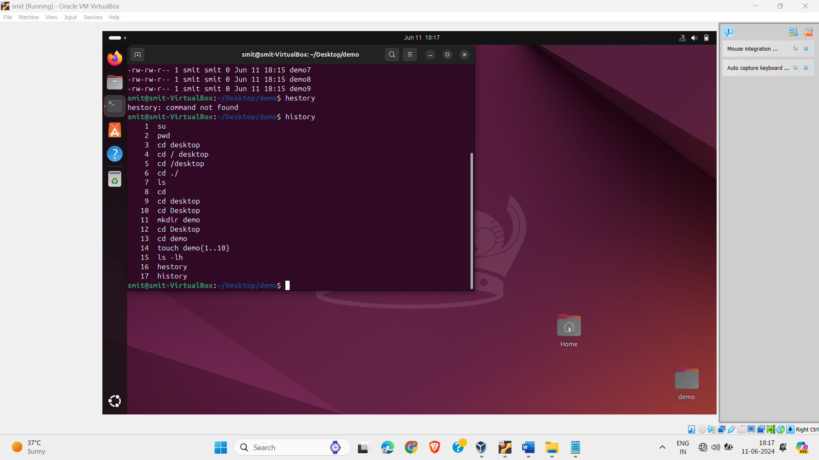

1. Make 10 files demo1,demo2,demo3,…,demo10 inside Demo directory.

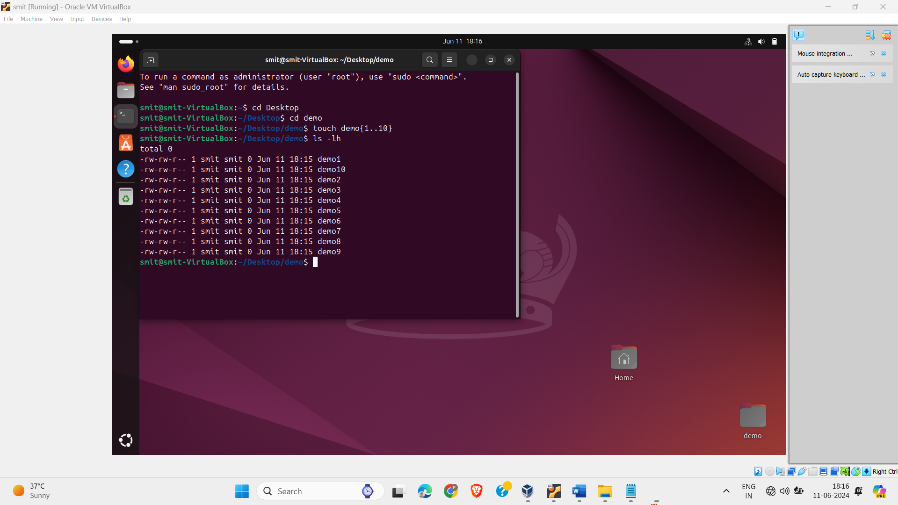

1. Add new user named “testuser”

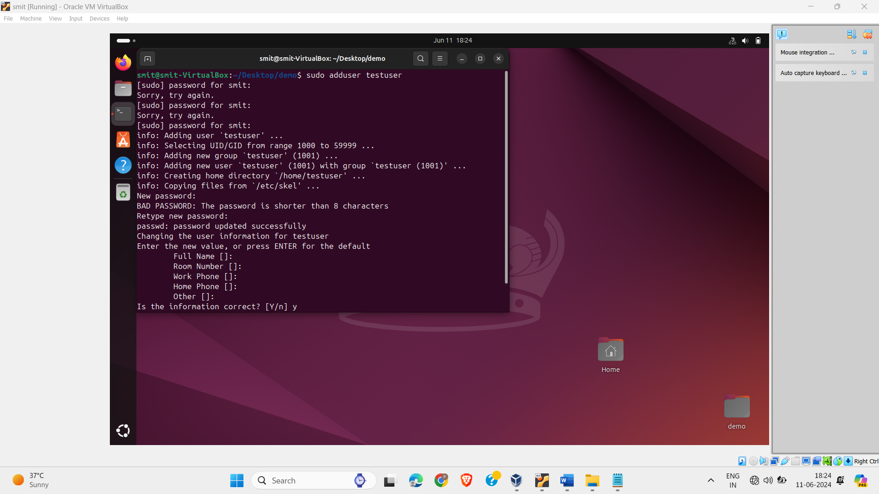

1. Verify that user has been added or not? Mention the steps that you have followed to verify!

Cd ../

Cat /etc/passwd

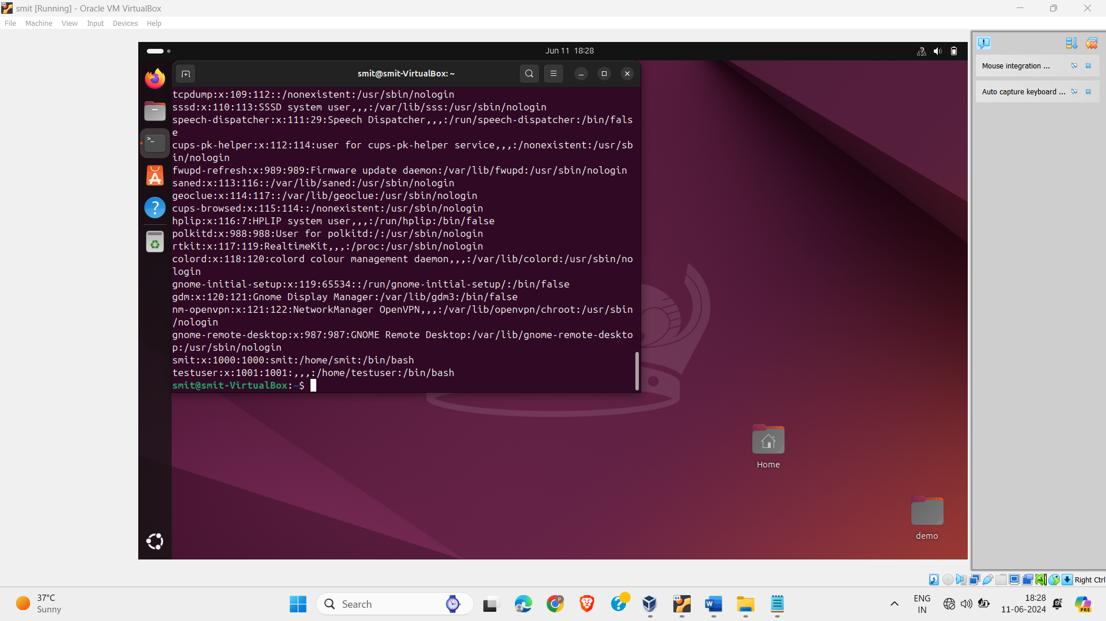

1. Login as testuser

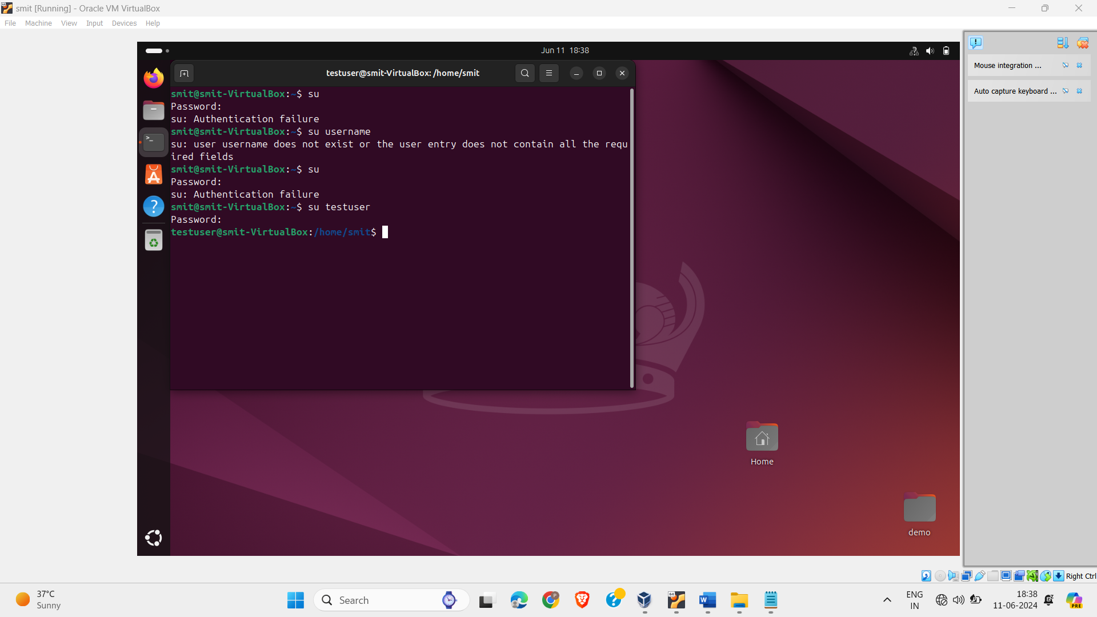

1. Create new file named “testuserfile” inside Demo directory.

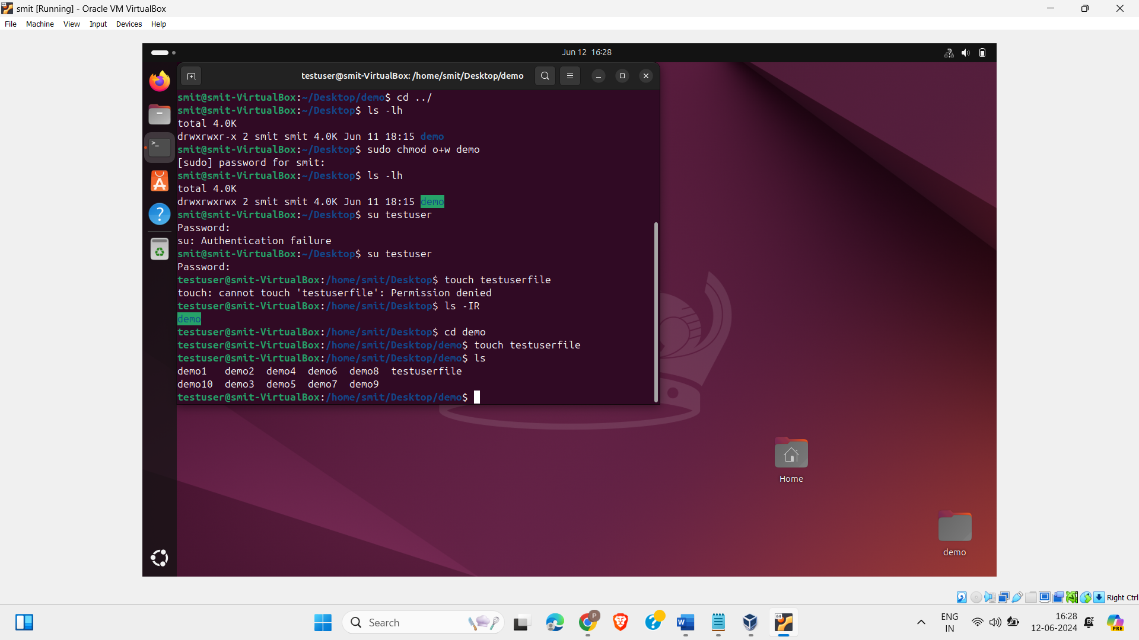

1. Exit from testuser

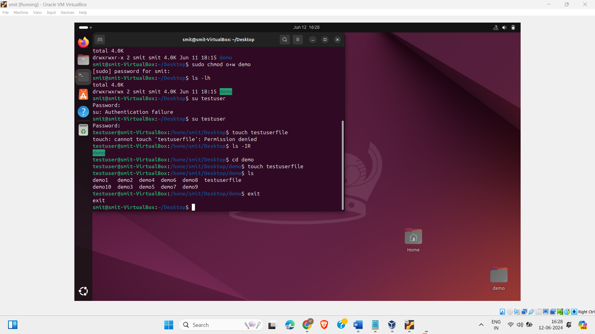

1. Change ownership of first 5 files (demo1, demo2, … demo5) to testusear

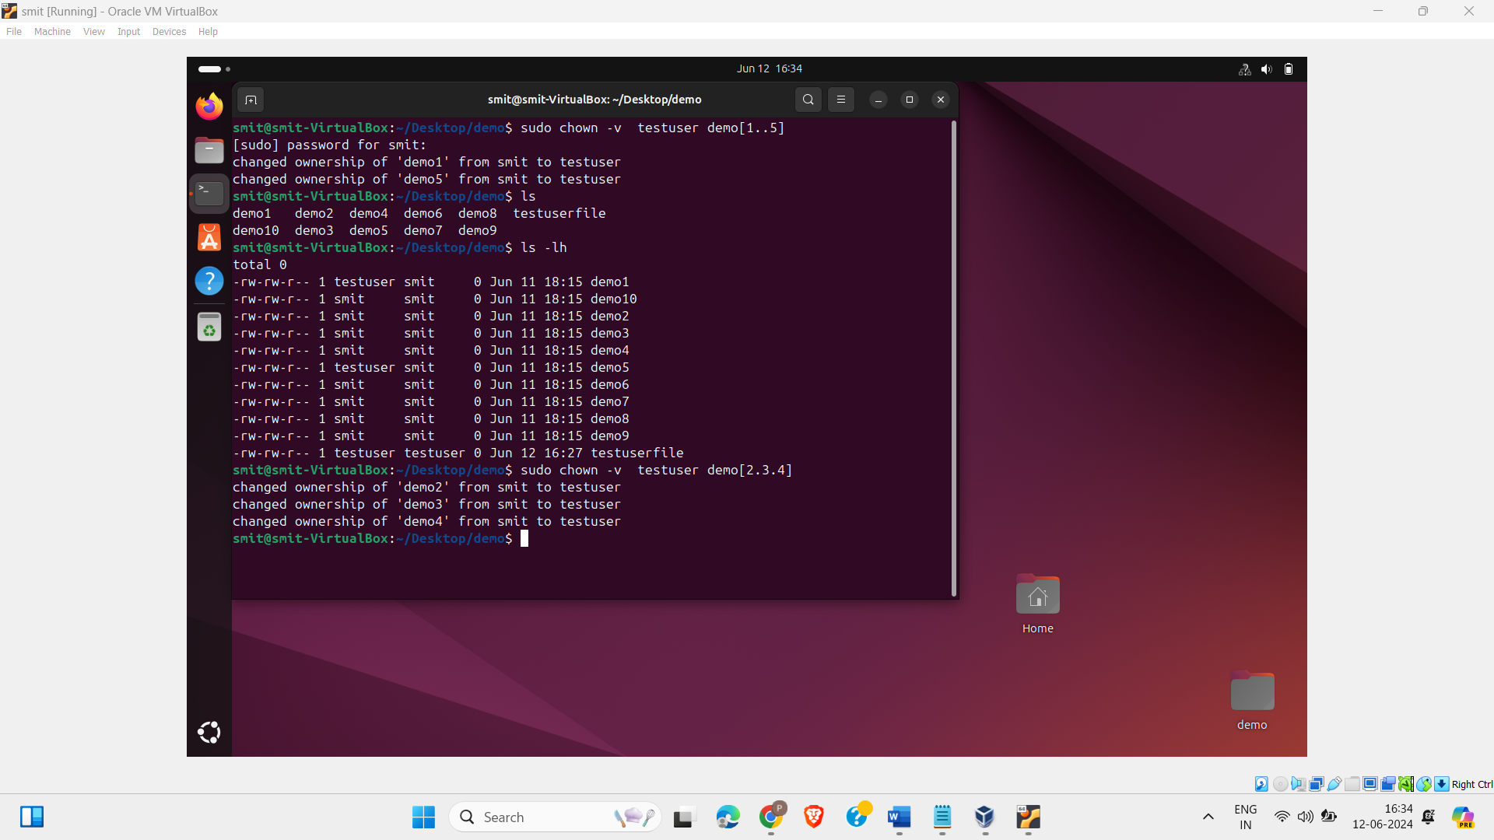

1. Create group named “HR”

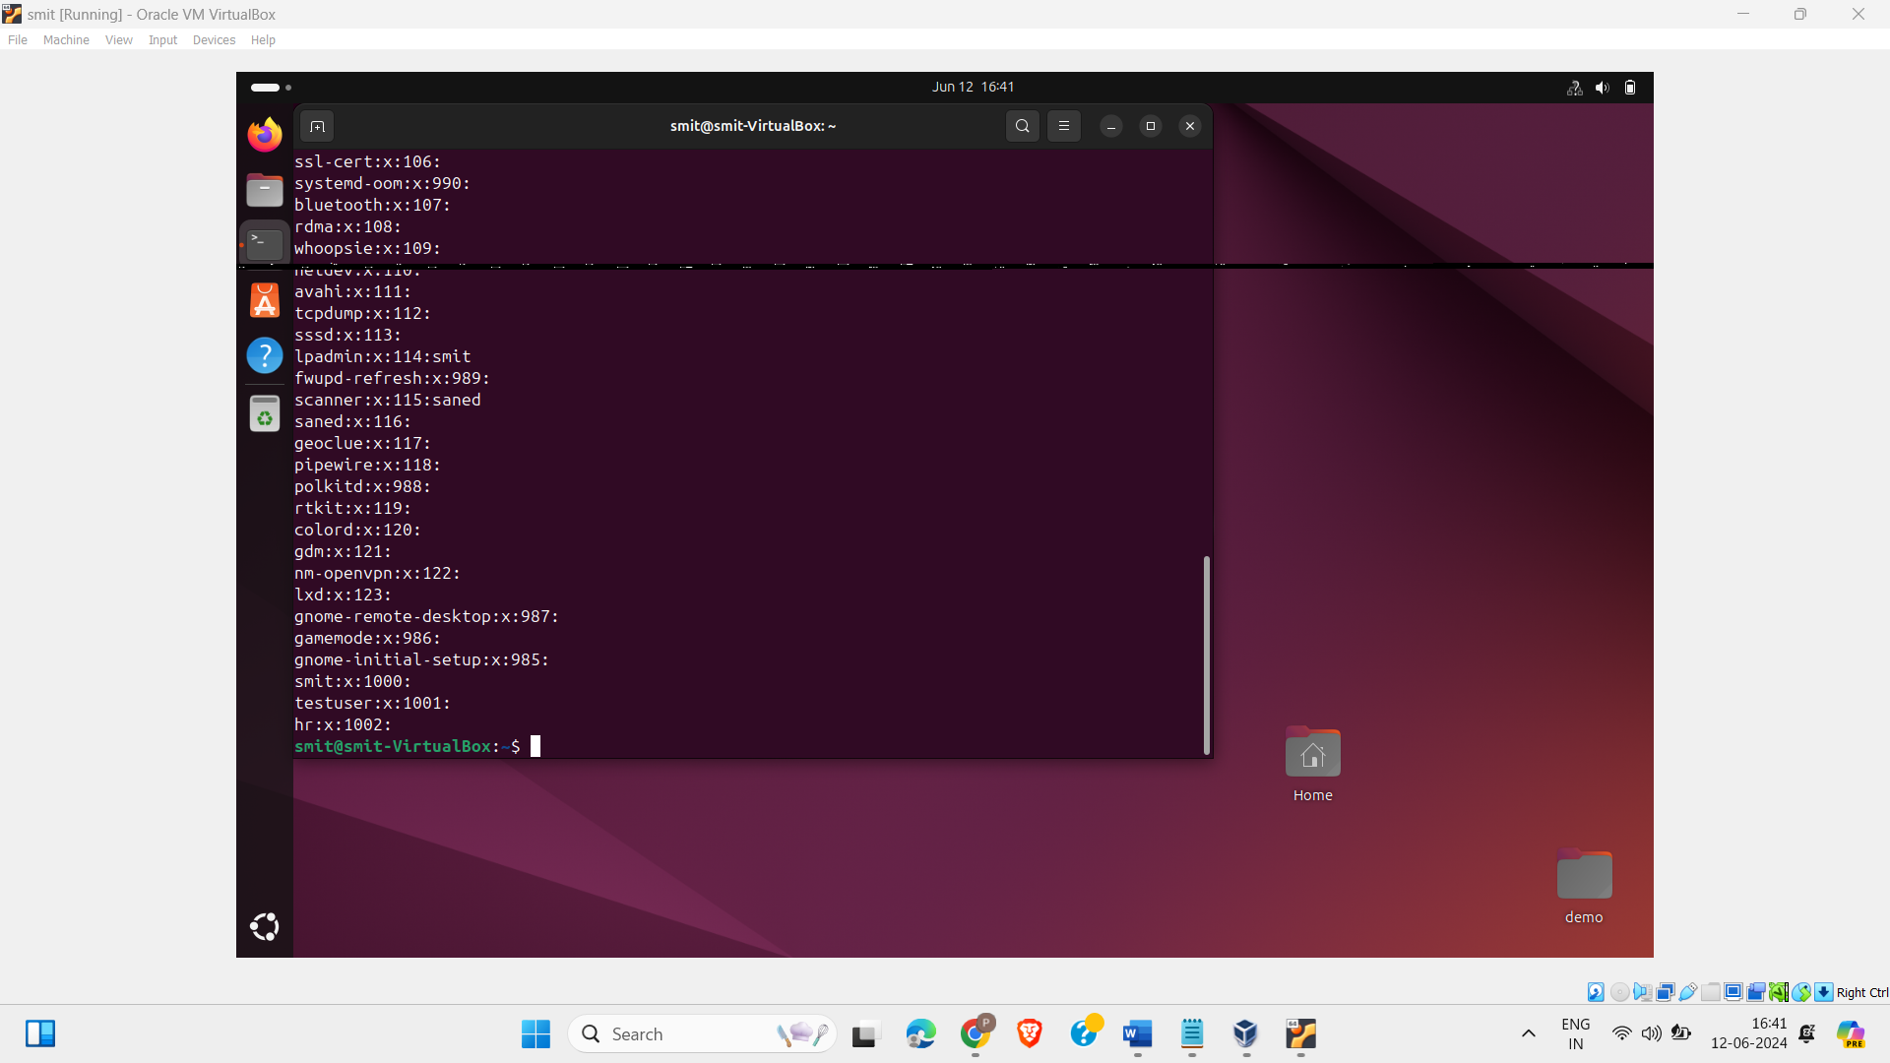

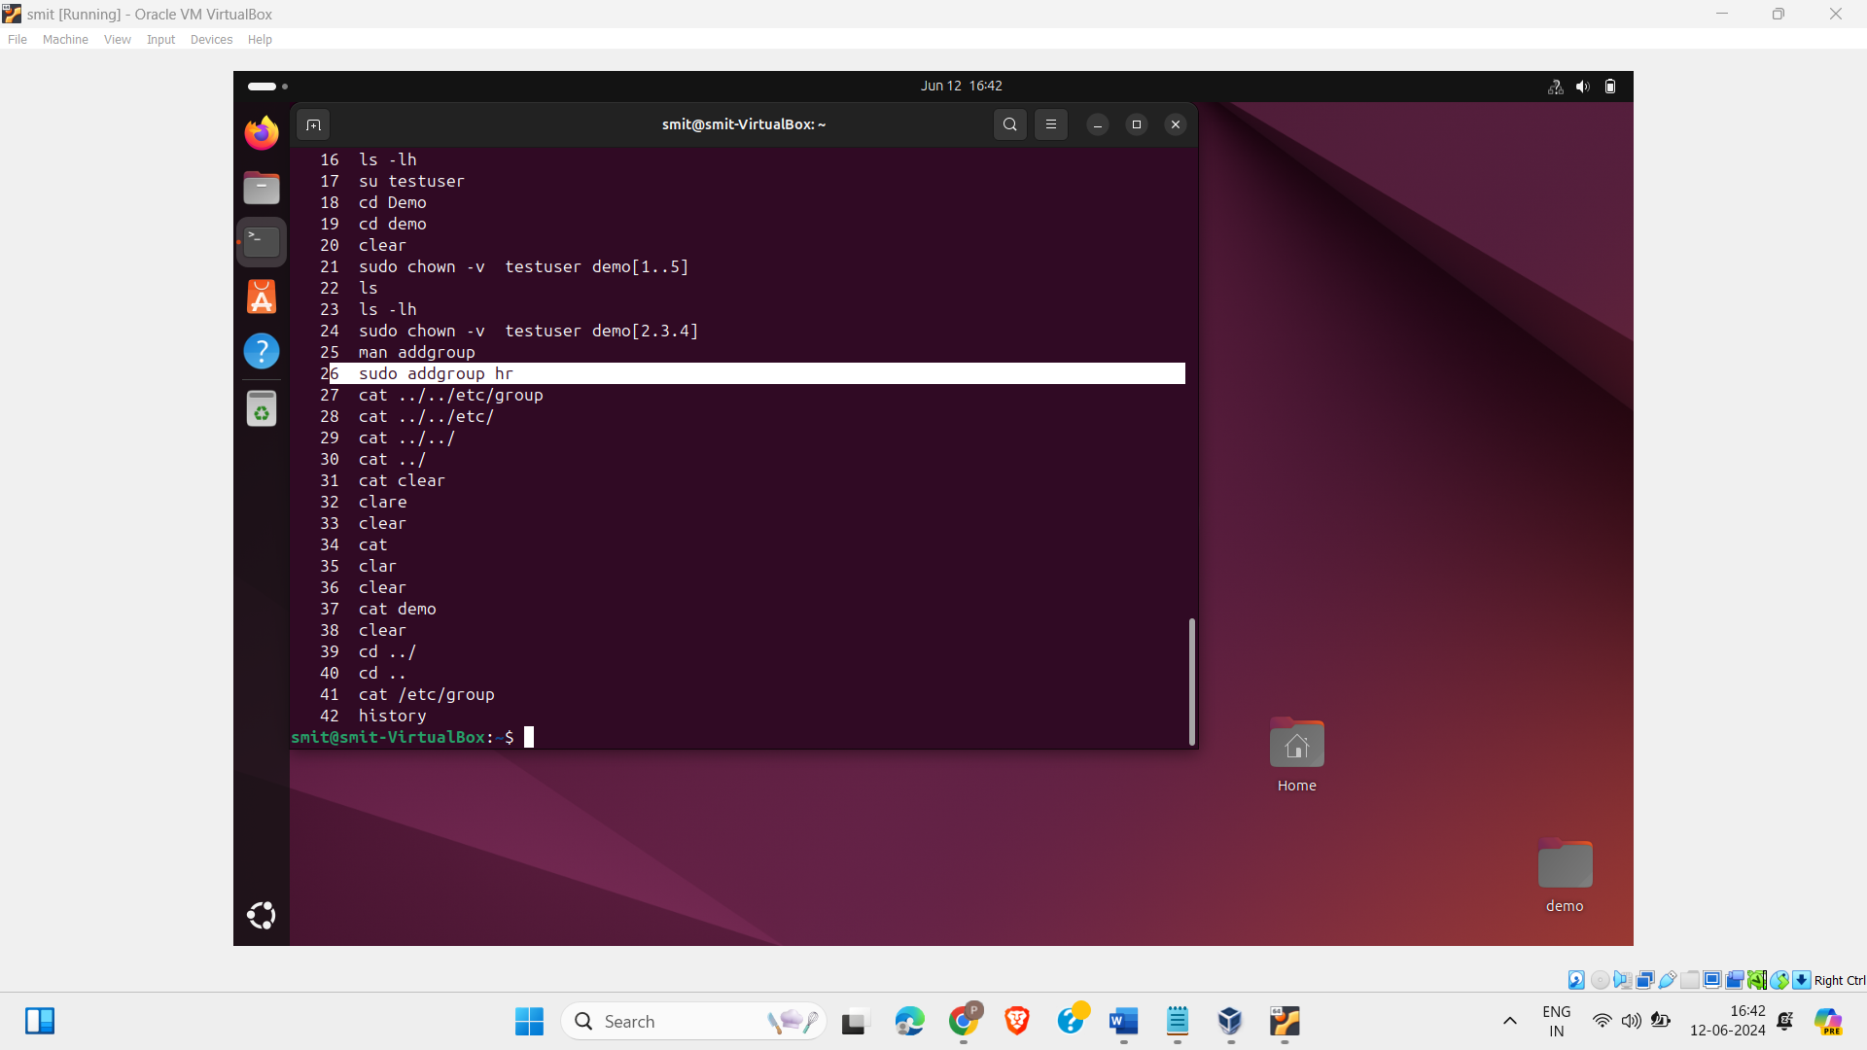

1. Add testuser and your current user to this group (“HR”)

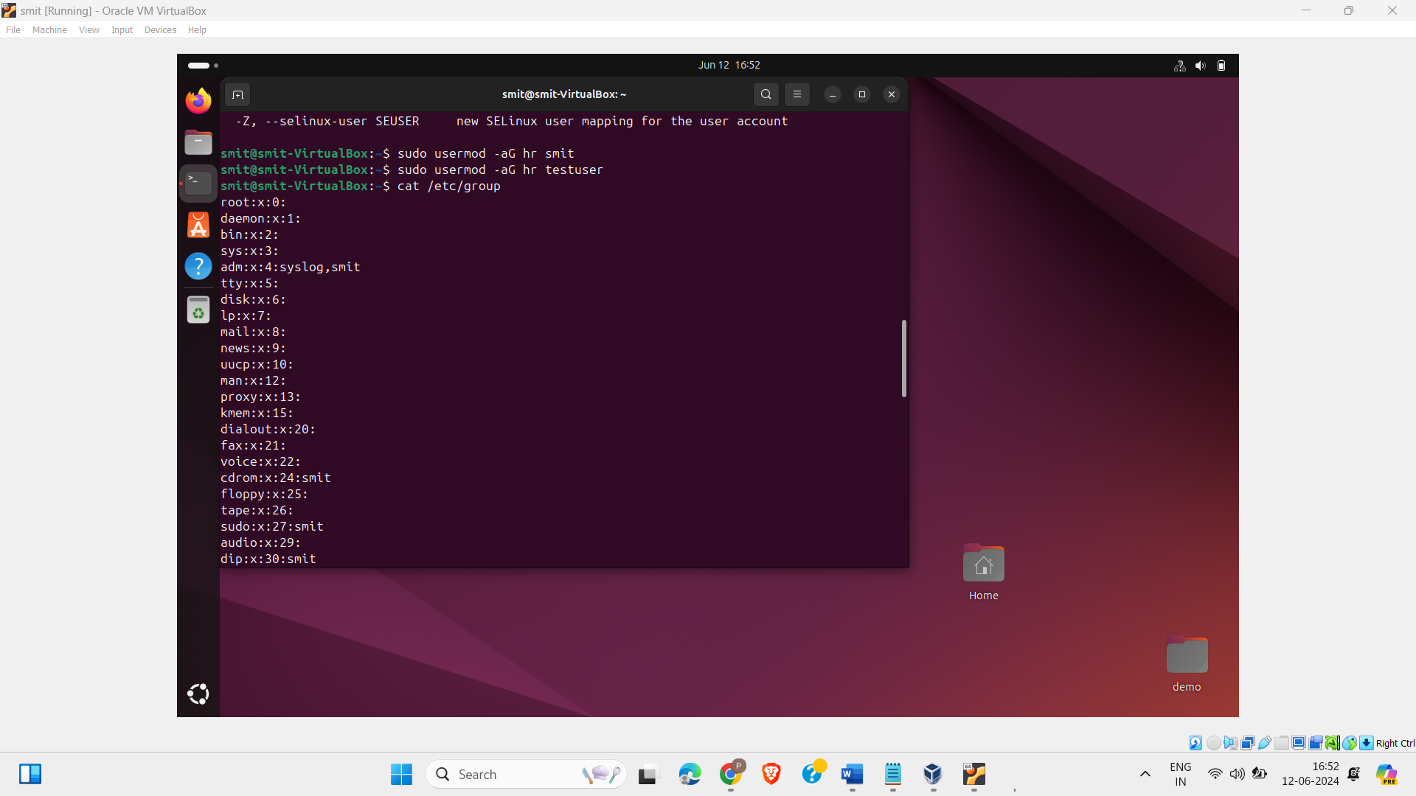

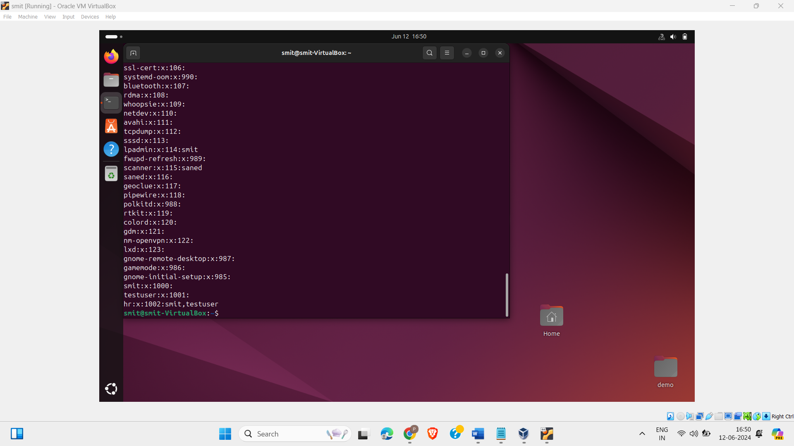

1. Remove read permission from all groups for last five files inside Demo directory (demo6, demo7, … , demo10)

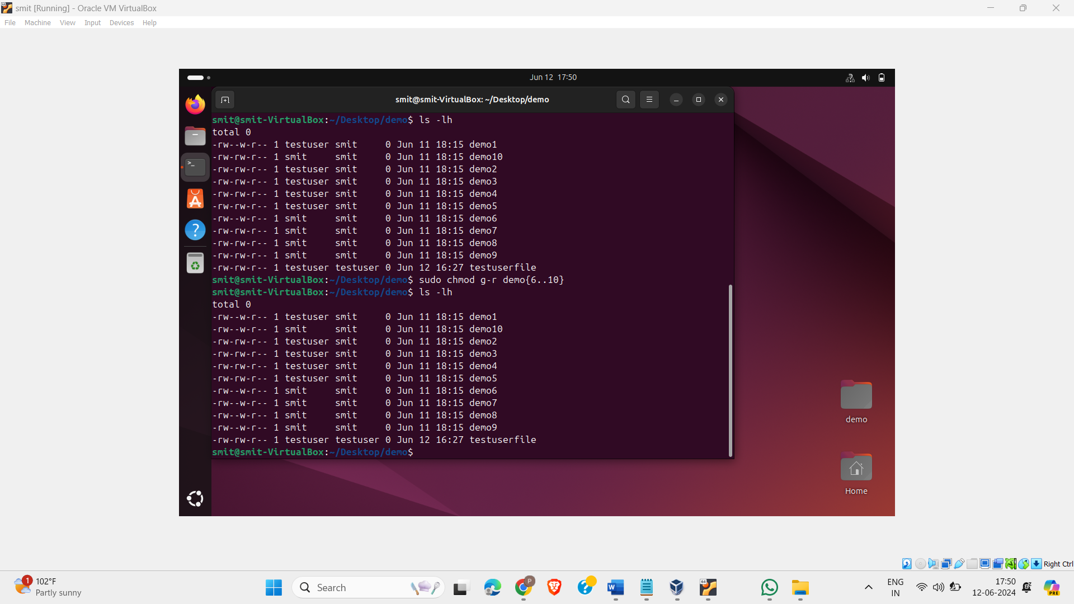

1. Delete first 5 files from demo directory with minimal number of commands.

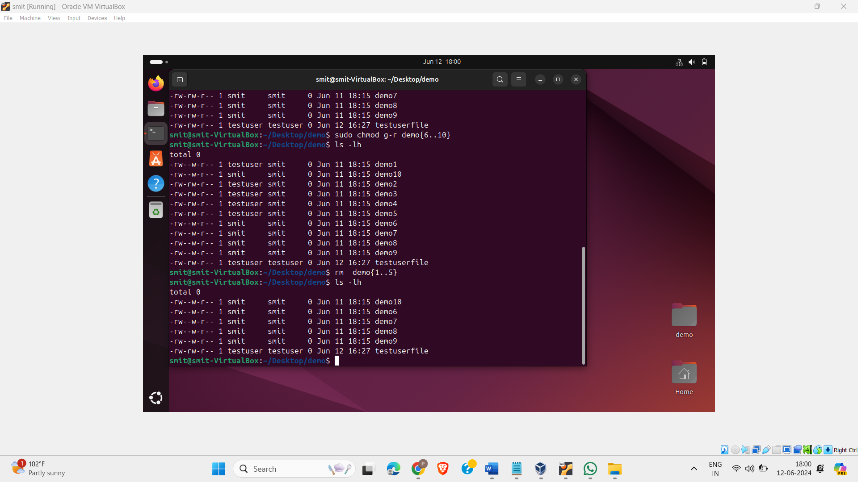

1. Remove group “HR” and verify it.

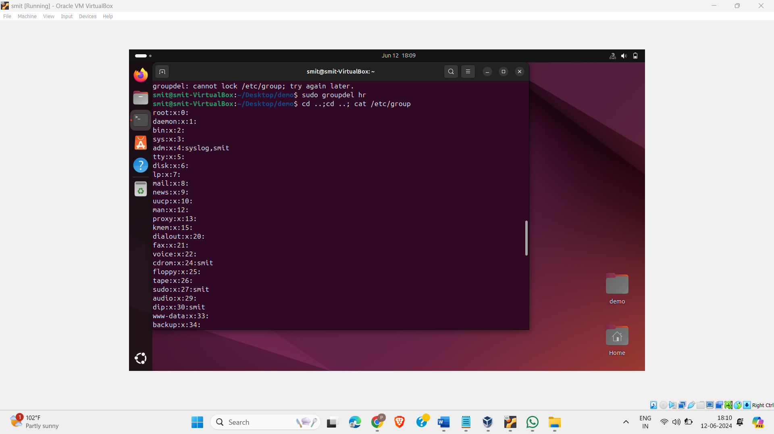

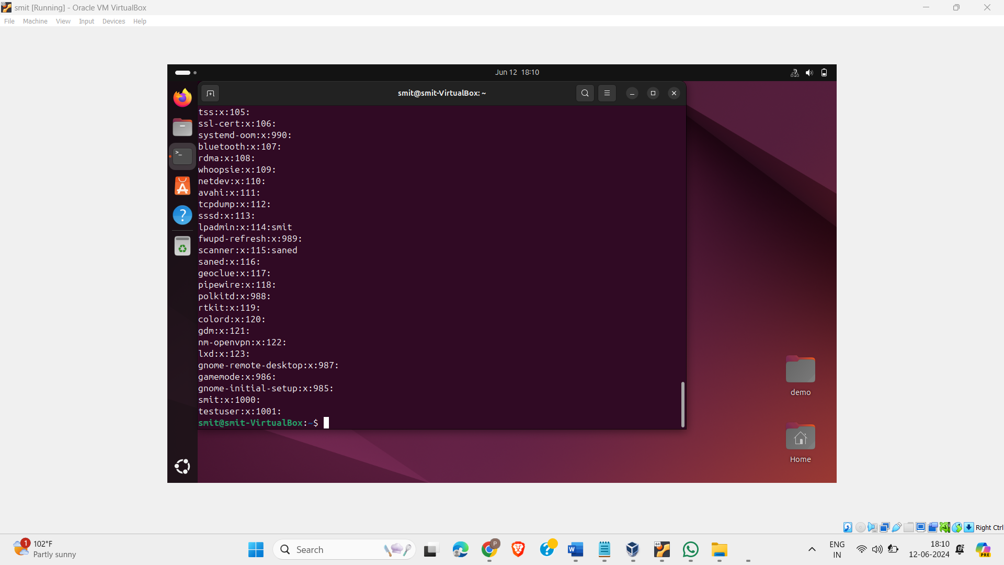

1. Remove “testuser”

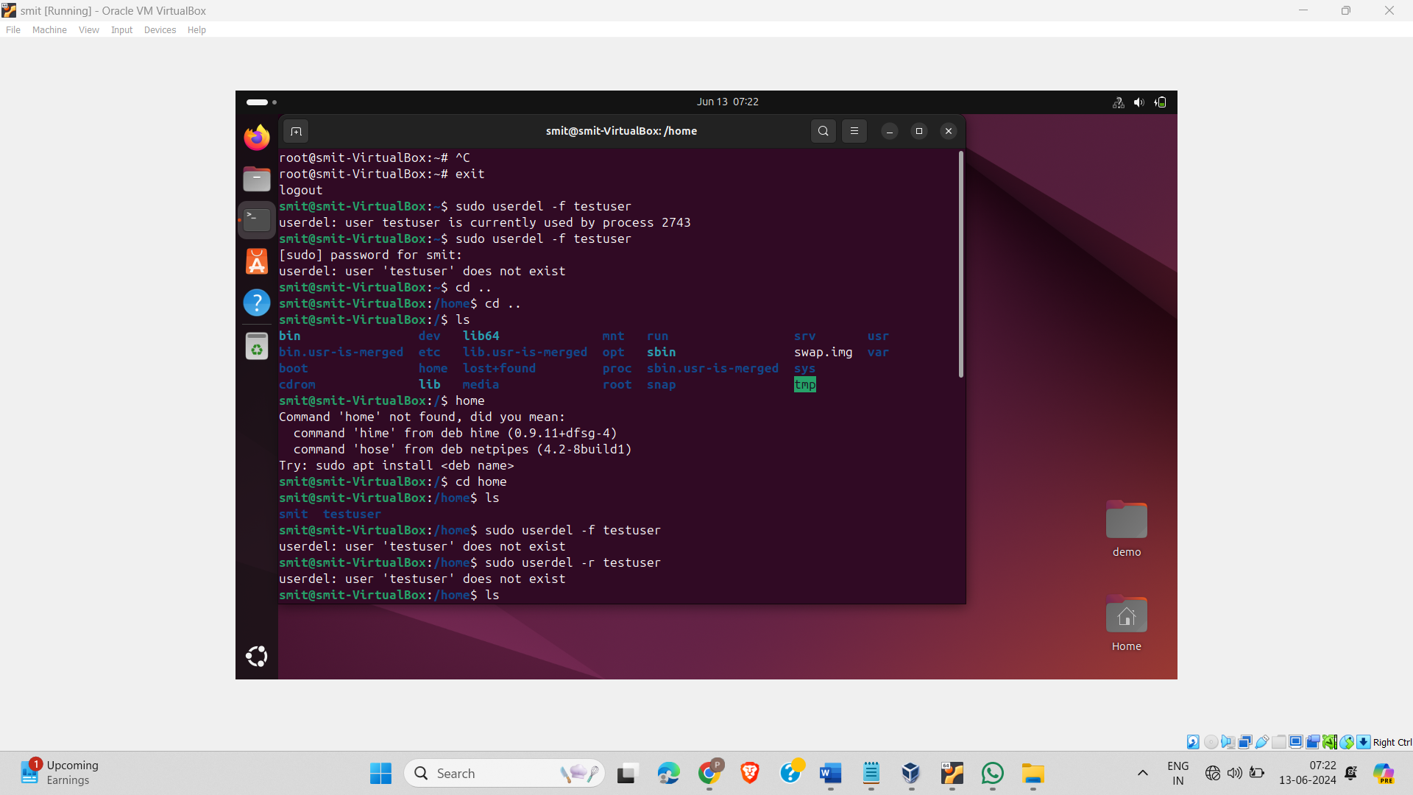

1. Remove Demo directory.

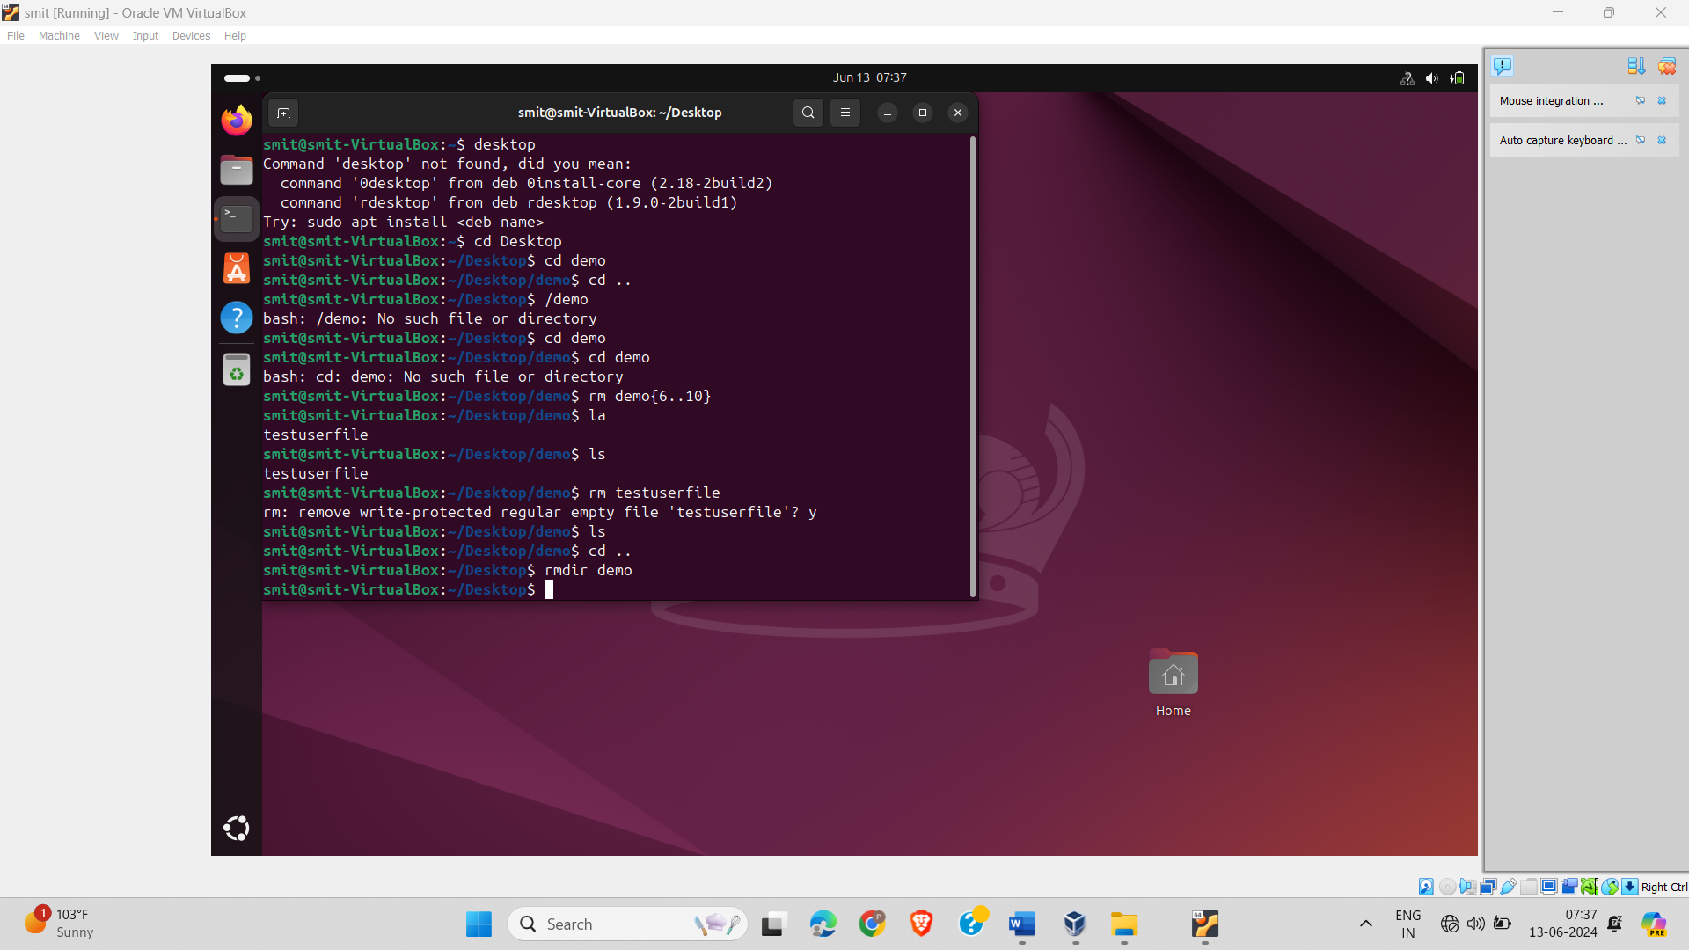

**Paste your cheat sheet here:**

usermod -L user (usermodification -L Lock user-argument)

sudo su -

man usermod (manual page by man comand)

cd

ls

ls -l -LH (long list)

display

user group other

permission -:drwx for user rw- etc

chmod +u binary number for each position

date +%R

file

cat (to print file contant)

head -n 5 filename

tail -n 5 ''

wc

touch filename(create file)

gedit

vim

apt-get

sudo apt update

sudo apt vim install

-press I for insert

-press esc for stop

-press both shift+:

w for write

q for save & quit

q! for quit furo

here in bin -file store for services by all the user

pwd

echo

clear

mkdir

whoami

rm

cat

rm -r

sudo adduser test

su username

chmod o+w filename

sudo chown test:test

usermod -aG

ls -l /etc/ | grap sudo

userdel -f

groupdel -f

**Write conclusion in few lines for above activity and today’s session:**